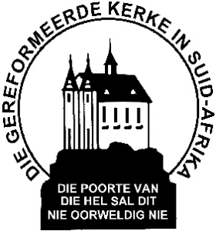
Gemeente Briefhoof
Letterhead of congregation

Declaration OF CONFESSING MEMBER AND FAMILIES
The Church Council of this Reformed Church declares herewith that the undermentioned were members of this church until today.
Confessing member(s)
Brother

Sister

Baptised member(s)

Because these members emigrated to ********** we commit them gladly to your pastoral care.
This Council witnesses as follows on the doctrine and life of the abovementioned members: They confess the Three forms of Unity: The Belgic Confession, the Heidelberg Categism and the Canons of Dordt. They were active members of this congregation.
Signed for the Council

__________________
Chairman
________________
Scribe

